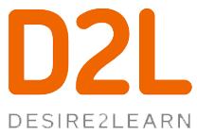

Dear Parent/Guardians,

In an effort to enhance communication and support student learning, we will be incorporating the use of Desire2Learn (D2L) into our program. This is a web-based learning management system that will allow us to post important information and content into a secure online environment.

What makes D2L secure?
The Ministry of Ontario has purchased the license to D2L (based out of Kitchener, Waterloo) and has rights to all of the information on its server. Therefore, we have legal rights to all of the content posted. As well, D2L is username and password protected and cannot be accessed by anyone other than the student with the proper login information.

To access our class website, students go to: dsbn.elearningontario.ca
(or through the students.dsbn.org bookmarks if you are signed into Chrome)

Students can access D2L using the students’ email and password. Parents/guardians are encouraged to use the login cards to help students log into D2L independently. The goal being that parents and students can engage in meaningful dialogue to support their learning. This is a great way to increase the home/school connection.

Hopefully you are as excited as we are to log in and stay connected. If you have any questions or concerns with regards to the use of D2L, please feel free to contact us.

See you online,

