Dear Parent/Guardians,

We are excited to announce that we will be using D2L Portfolio to capture student learning this year. This tool allows us to upload images, video and audio into secure and private Portfolios for each student. Some of the great features of Portfolio are;
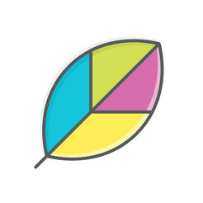
- Each student will have their own Portfolio that only they can view
- Students will be able to access all artifacts from previous years
- Students/Teachers can comment on artifacts
- Username and Password Protected
- Licensed and Supported by the Ministry of Ontario

To Access Student Portfolios

Go to dsbn.elearningontario.ca  Log in using DSBN Email and Password | In Top Right corner of page  click on student’s name, then  My Portfolio | Select Student’s Class  (Current year or previous years below)
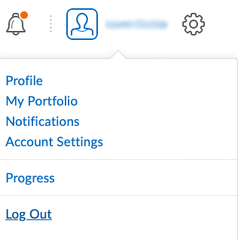
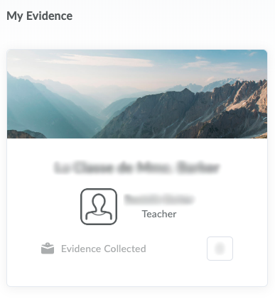
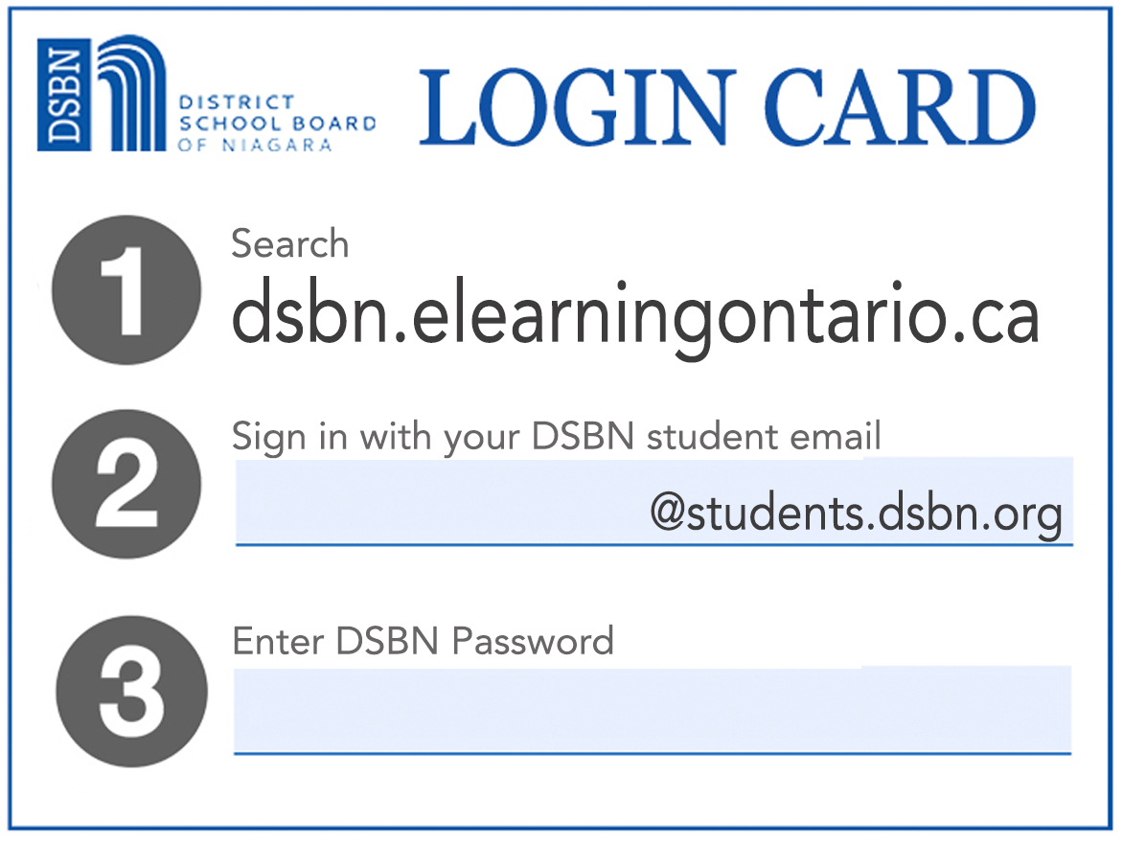

We hope that you enjoy exploring these Portfolios together. They are a great way to keep your informed about their learning. Please feel free to contact me if you have any questions.

See you online!

